Mannix, E., & Neale, M. A. (2005). What differences make a difference? The promise and reality of diverse teams in organizations. Psychological science in the public interest, 6(2), 31-55.
Building on the similarity-attraction theory prepare a small presentation to the class explaining the potential difficulties the organization will have managing Stephanie’s case

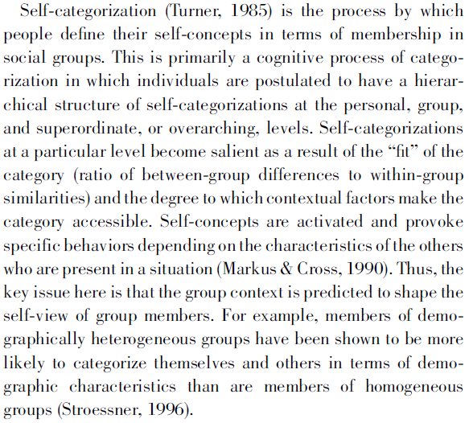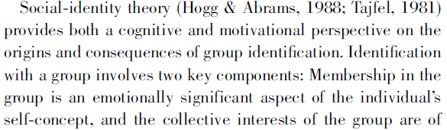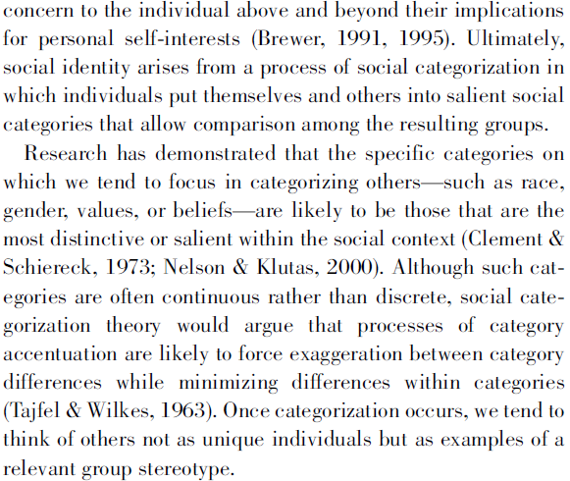
Mannix, E., & Neale, M. A. (2005). What differences make a difference? The promise and reality of diverse teams in organizations. Psychological science in the public interest, 6(2), 31-55.

Building on social identity and self-categorization theories prepare a small presentation to the class explaining the potential difficulties the organization will have managing Stephanie’s case

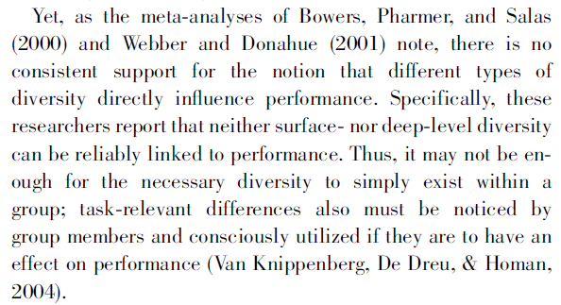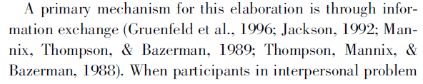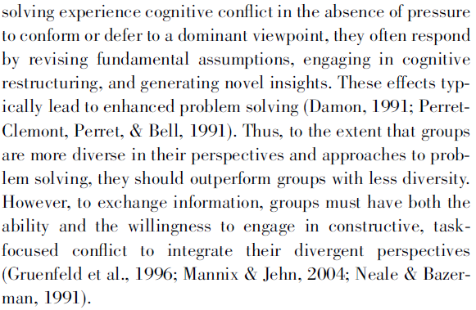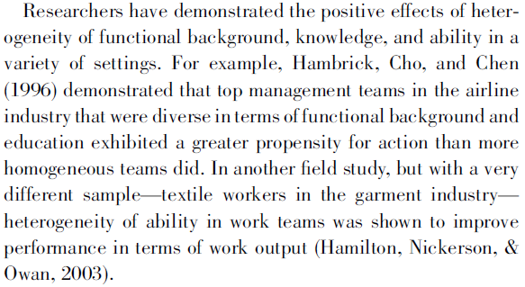
Mannix, E., & Neale, M. A. (2005). What differences make a difference? The promise and reality of diverse teams in organizations. Psychological science in the public interest, 6(2), 31-55.

Building on information processes theories prepare a small presentation to the class explaining the potential advantages the organization will have in effectively managing Stephanie’s case

